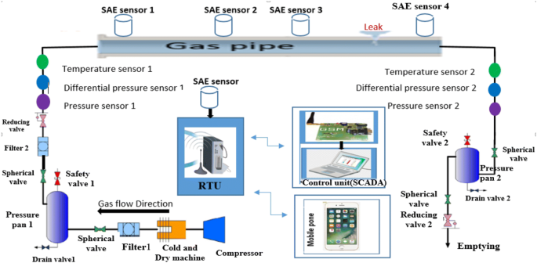Solution architecture for gas leakage monitoring and alerting system